Release 1.0 NEW YORK STATE - LEVEL 0 HISTORICAL

Help for Student Update
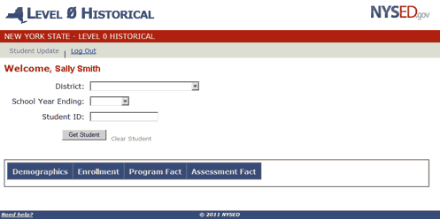

General Overview
The Level 0 Historical application will provide the sole process for updating individual student historical data that currently resides in the data warehouse. Historical records are defined as any data warehouse record submitted prior to the current school year. The data areas currently available for view and future update are Demographic, Enrollment, Programs Fact, and Assessment Fact.
Once authenticated as a valid user, you will be able to access SIRS (Student Information Reporting System, NYS reporting data elements) school district information using district name, school year, and local student id as identifiers. Historical information will be displayed for the identified student and may be updated according to the Level 0 business rules that exist for each school year.
The "Need help?" link at the top and bottom of each screen will take you through the necessary steps for retrieving and updating a student and provide you with any notes and error messages you might encounter within each category. If you should need additional assistance, please contact your Level 1 operator.

1. Retrieving a Student:

From the Dropdown menus:
Select the District if you have access to more than one district:
Note: If a district has not been selected when a student is searched for, the following message will be displayed:
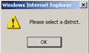
Select the desired School Year:
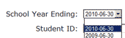
Note: If a school year has not been selected when a student is searched for, the following message will be displayed:
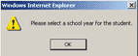

Enter the desired student's local Student ID:
Note: If a student ID has not been entered when a student is searched for, the following message will be displayed:
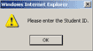

Click the "Get Student" button or Click on a Category Tab:
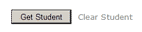Or
The "Get Student" button will default to the Demographics view and return all authorized available records for the selected student.
Clicking a specific category tab will allow you to view the records associated with that tab first. Likewise, all authorized available records for the selected student will be returned.
The screen will be grayed-out and the Level 0 Historical icon below will flash while data is being retrieved:
Please wait.
Note: If student ID number does not exist in selected school year, the following message will be displayed:
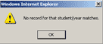
Click OK and re-enter a valid student ID or select a different school year.

2. Viewing a Student:
Information for the selected student will appear under each Category by school year.
Use scroll bars as necessary to view all available data (left to right, top to bottom).
Toggle between the Category and/or School Years to view the retrieved data for the student.
For example, to view Enrollment data for the 2009 school year, click on Enrollment and 2009–06–30.
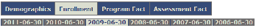
Only NYS Reporting fields will be displayed for all Categories.
"State Code :: Description" combination will be originally displayed for each record, where applicable.
Records that are not owned by your district will be italicized and shaded in gray.
If the business rule changes for a data element, the supported rule will be the rule that was in place for the particular school year and will reflect in the retrieved data.
For example: Beginning in the 2010–11 school year, Hispanic indicator was introduced and Race/ethnicity rules changed. While changes prior to 2010–11 do not require Hispanic indicator, Multi-racial and Hispanic ethnic code will still be displayed under Ethnicity and Race 1.

3. Clear Student:

Click the "Clear Student" link (located next to the Get Student button) to clear all student information from view:

4. Log Out:
Click the ‘Log Out’ link (located at the top left of the screen) to end your session.
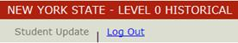
Please note: This session will automatically log you out after 15 minutes of inactivity.

Demographics
Demographic data elements describe the individual student. These data elements are also used in NYSSIS (NYS Student Identification System). Data is used for district and school accountability subgroups and cohort membership.

1. View Functionality
Only NYS Reporting fields will be displayed.
Display will include all school years for all authorized available records for the selected student.
Note: If selected student does not have data in a school year, other than the originally selected school year, the following message will appear:
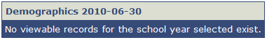

Enrollment
School enrollment data elements define reportable enrollment actions (entries and exits). For any given student there will be at least one – and probably more –school enrollment records per school year. All reportable students require a school entry enrollment record for each year. Additional records are required when a student changes grade level and/or building during the same school year. Data is used for district and school accountability and cohort membership. Calculations using these data will be able to provide dropout and graduation rates, school enrollment counts, special education snapshot data, and assessment participation rates.

1. View Functionality
Only NYS Reporting fields will be displayed.
All enrollments will be displayed for any school year, where enrollment activity exists, including prior school years even if the student was enrolled in other districts.
Note: Any Office of Mental Health (OMH) enrollment data will not displayed.
Display will include all school years for all authorized available records for the selected student.
Note: If selected student does not have data in a school year, other than the originally selected school year, the following message will appear:
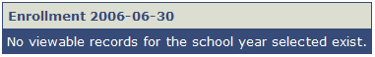

Programs Fact
Programs Fact data elements define students’ involvement in reportable program services. Programs Fact also includes transactional data: where each program service must be reported for each student for each school year. Programs are defined as attributes of a student that can change over time and have specific starting and ending points.

1. View Functionality
Only NYS Reporting fields will be displayed.
Districts can only view Program records that they submitted.
Note: Districts cannot view any calculated program records (Former LEP or formerly disabled).
Display will include all school years for all authorized available records for the selected student.
Note: If selected student does not have data in a school year, other than the originally selected school year, the following message will appear:
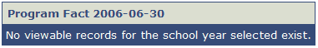

Assessment Fact

1. View Functionality
Only NYS Reporting fields will be displayed.
Vendor scored assessments will not be displayed (NYSTP 3–8 ELA/Math, NYSAA, NYSESLAT).
Future assessments reported by another district will not be displayed.
Display will include all school years for all authorized available records for the selected student.
Note: If selected student does not have data in a school year, other than the originally selected school year, the following message will appear:
