Release 1.0 NEW YORK STATE - LEVEL 0 HISTORICAL

Login Screen Help

Please enter your UserID:

Please enter your Password:

Click the "Submit" button to complete the process:
Note that if a password is not entered, the following message will be displayed:
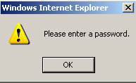
If userid and/or password are not valid, the following message will be displayed:
