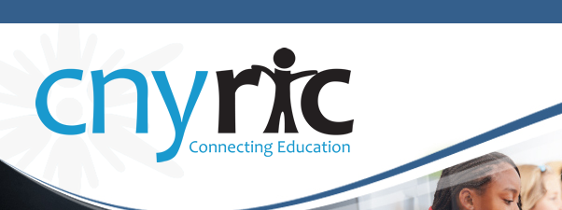
Central New York Data Analysis Community (CNYDAC)
Oct. 9, 2014
Time: 10:00 AM- 12:00PM
Distance Learning Center Room – OCM BOCES Admin. Building

The CNY Data Analysis Community (CNYDAC) exists to provide direction, expertise, and support to component schools for intelligent and responsible use of data to improve student achievement.

- Welcome
- Teacher Surveys for Programmatic Decision-Making
Chris Klivak, CNYRIC
Will share two examples of surveys that have been administered to K-12 staff in two districts in order to guide decisions related to RTI as well as Writing.
- Using BARS Reports for Assessment Results Analysis
Brent Bowden, Central Square School District
How to access and use the BARS reports for analysis of student performance.
- Reflection and Evaluation

