INACTIVATION OF INTERVENTIONS

Year End Procedures

Pending Interventions

All pending interventions need to be examined for the 2012-2013 school year. If the student did not receive the service, the intervention should be deleted. If the student did receive the service, the appropriate information needs to be included in the student’s intervention to make it active. The intervention should be marked inactive with the proper end date.

Active Interventions

All active interventions need to be inactivated from the 2012-2013 school year. There are several features within the application that can be used in order to inactivate interventions or the intervention can be inactivated manually. Each option is discussed in detail below.

Manual Entry

Each provider can manually update their intervention status from active to inactive and mark the intervention with the proper end date.

Inactivation Rollover

Inactivation Rollover will inactivate all interventions that match certain criteria. The Inactivation Rollover can be found on the My Student tab under Mass Data Entry or the Maintenance tab under Mass Data Entry.

Note: The Inactivation Rollover feature will not create new interventions in the following school year.

To perform an Inactivation Rollover:

- Click on the Inactivation Rollover Link
- Enter the following:
  - School year: 2012-2013
  - Grade: Enter the grade range for the interventions to inactivate
    - Note: This grade refers to the interventions grade and not the demographic grade
- Site: Enter the site where the intervention was given
    - Note: Only one site can be processed at a time
  - End Date: Enter the end date for the interventions
    - Note: This can be applied to all interventions or only the interventions that currently have a blank end date

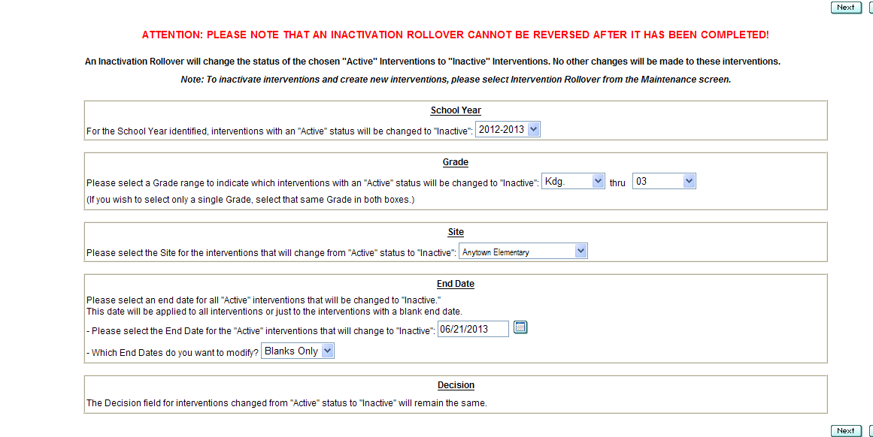
Above is the Inactivation Rollover Criteria Screen

- Click Next

- Review Criteria and Select Interventions to Rollover – All interventions that will be inactivated should be checked. Any intervention that will not be inactivated should be unchecked.
  - Note: AN INACTIVATION ROLLOVER CANNOT BE REVERSED AFTER IT HAS BEEN COMPLETED!

Below is Review and Select Intervention Screen

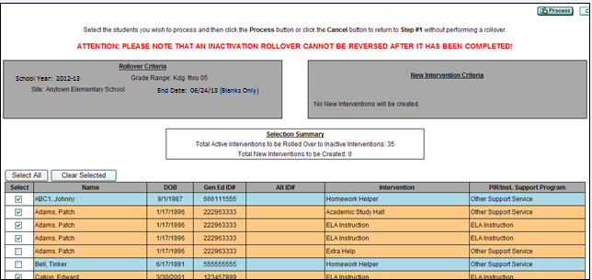

Review the rollover criteria: School year, Site, Grade Range and End date

Selection Summary box shows the number of interventions that are going to be inactivated.

Uncheck students if you do not want to close the intervention.

- Once a review is done click

- A warning message will pop up. Read the message and click Yes to Continue or No to Cancel the Rollover.

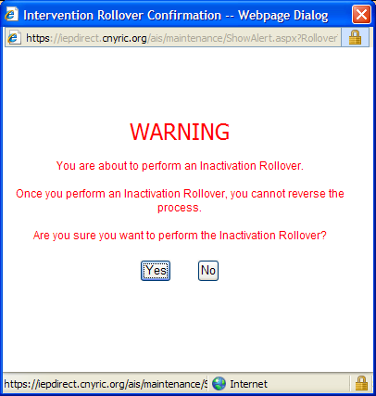

Warning Message

Below is the Rollover History Screen

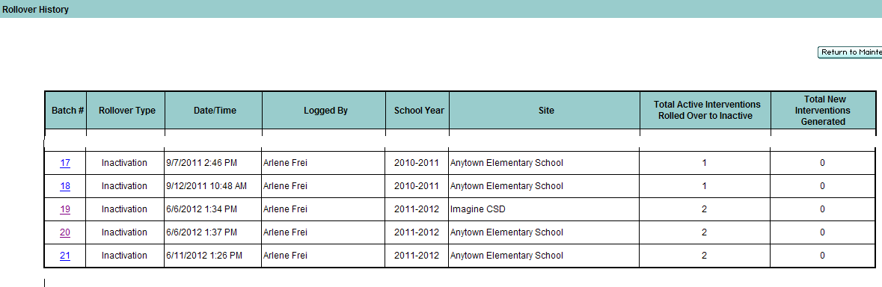

- The Rollover History screen will appear. Click on the last batch number to confirm your rollover.
- Either do an Inactivation for the next site or you are finished.

