Star Assessment Export Files for Upload to RTIm Direct

Administrative Rights are necessary in order to Export Assessment Files.

Select Personnel, Students, and Parents

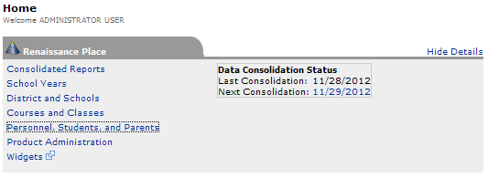

On the next screen click Export Information which is under Related Student Tasks.

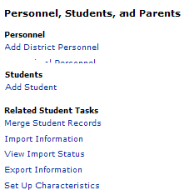

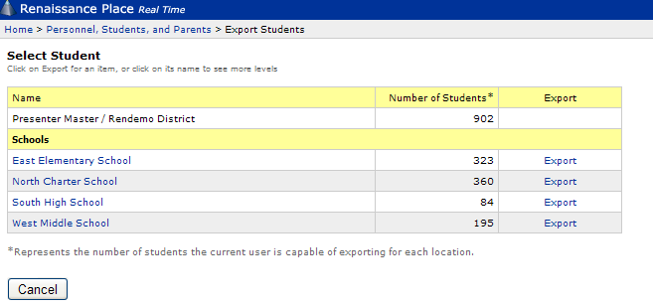

Select the School you want to export and click Export

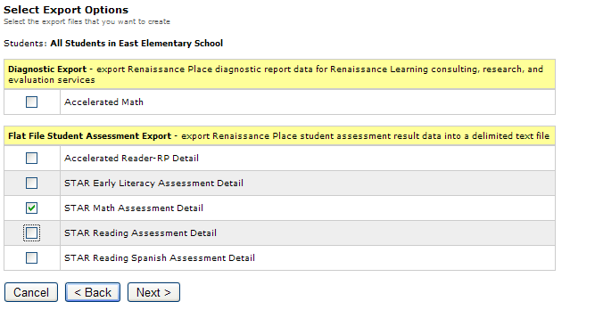

Select the Product(s) you want to download. In the above example Star Math Assessment Detail is selected.

Click 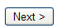

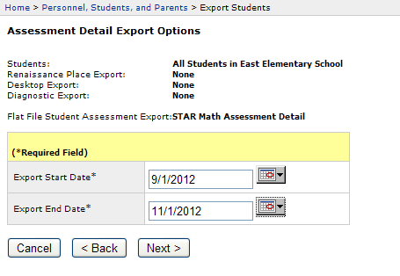
Choose your export dates; Click .

Wait until it is done generating the file(s).

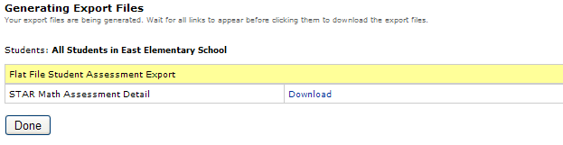

Click
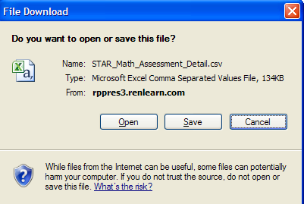

Save and name your csv file. Then click Done.
You will be brought back to “Personnel, Students, and Parents” menu where you can select “Export Information” for the next building and assessment until you have exported everything you need.

For each file you download, you will need to do the following before uploading to RTIm:

- Modify the assessment file from STAR by deleting the first line.

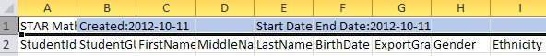
Delete lline

- Format the Date Taken Column from a date timestamp to a date.

To do so, you can click on the column to highlight (as shown above), then select “short date” from the drop-down menu when on the Home tab:

The result should be dates in the format of MM/DD/YYYY:

- Save as a csv file.

Now your file is ready to be uploaded into RTIm Direct.

RTIm Direct
Maintenance Tab
State/Local Assessments
Import Assessment Data

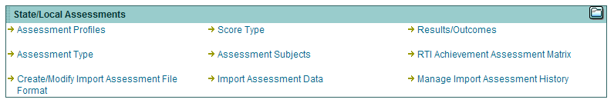

Click Import Assessment Data to receive the following view.

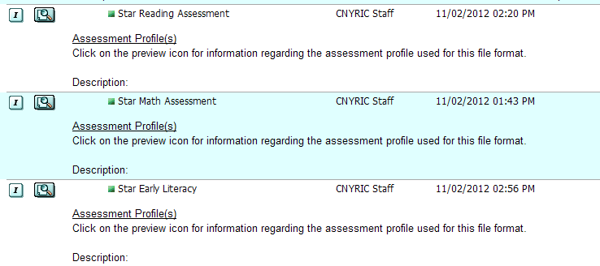

To see the assessment profile - click the magnifying glass in front of the assessment. This step is NOT necessary, but helps if you are troubleshooting errors.

SAMPLE PROFILE: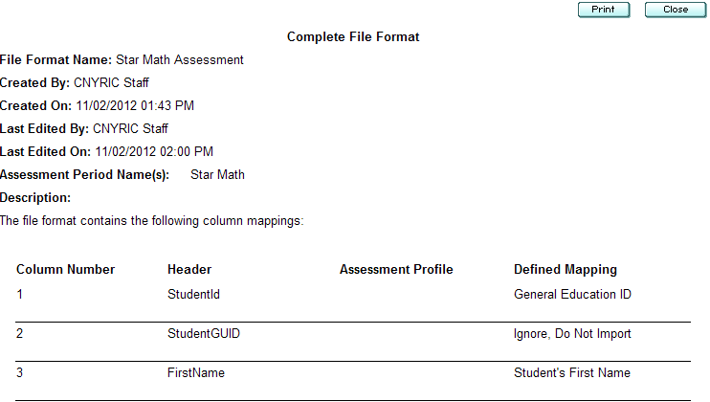
To begin the upload, click the in front of the assessment you want to load.

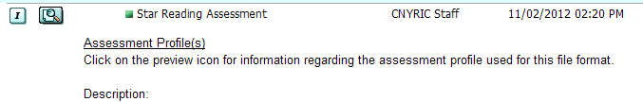

The following window will appear.

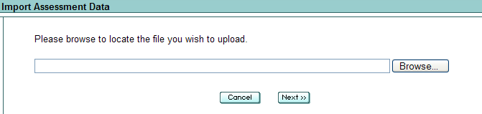

Click browse to find your csv file for the assessment you are loading. Choose your file. Click Next.

If it is the wrong format file, you will receive the following error message:

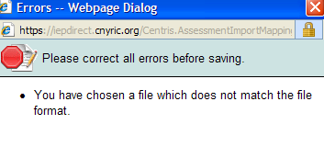
If the file is in the correct format, the following message will appear. Click Done.

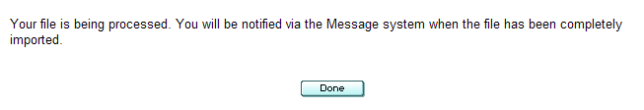

When the upload is complete, you will receive a message in the Messaging Tab:

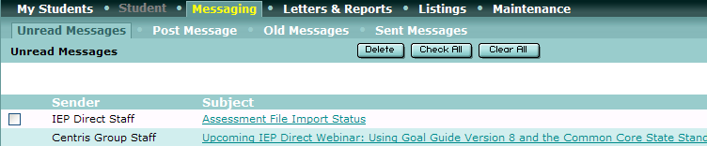

Click on the message to read it:

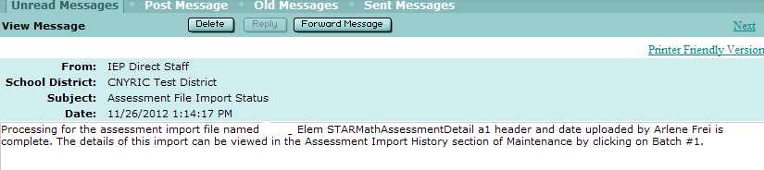

You can review the batch information by going to Maintenance Tab; Manage Import Assessment History

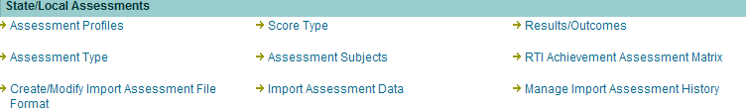

To view what was uploaded click the pencil. (see example below)

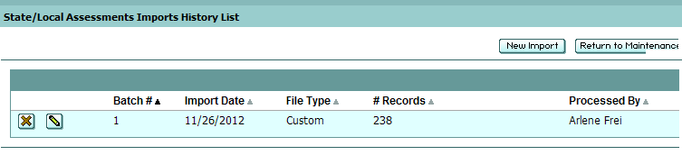

To delete what was uploaded click the

Errors are at the top of the page in red and can be printed.

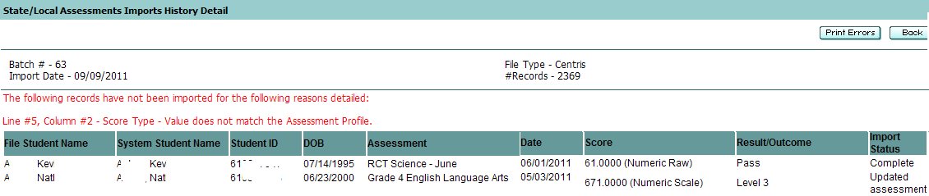

Import status will indicate complete if uploaded, or be in yellow if student is not found.

