Filter to View All Students

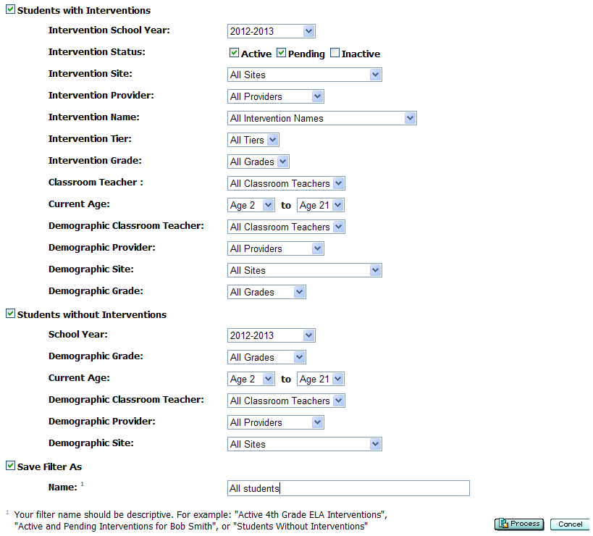

To see all students you must check in front of each section.

If you want a certain grade you will need to change the demographic grade drop down from all grade to the grade you want to see the students.

To save and name a filter check the last section and type in the unique name.

