STAR Math Scaled Score Correlation to NYSTP Achievement Level
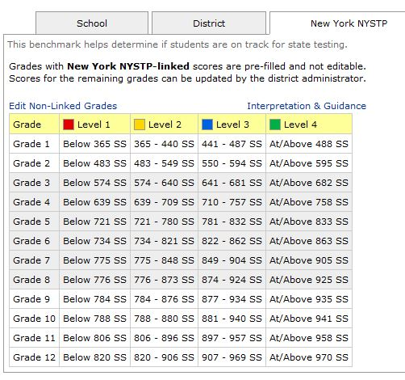

STAR Reading Scaled Score Correlation to NYSTP Achievement Level
