Level 0 – v21.0 Release Notes

Area | Purpose | Rule Text | Error Message
Enrollment | The Department needs to identify program locations for reporting (e.g. CTE). Creates an enrollment information check to warn BOCES when reporting a student with the overall BOCES location. | BOCES overall code should not be reported for enrollment locations, or you will receive the following [information] warning: | EE2111 v21.0 Student location should be a virtual location - Please review.
Enrollment | Establishes reporting requirements aligning specific credential types (Diploma Types) with associated enrollment exit types. Excludes Partner Project Fact students from these specific mappings. | Beginning on June 30th of the reporting school year (excluding students with Partner Project Fact records), a Credential Type Code of 204, 221, 238, 255, 272, 289, 306, 323, 340, 357, 374, 391, 762, 813, 779, 796, 068, 069, 070, 612, 680, 697, 714, or 731 without an exit enrollment code of 799, OR a Credential Type Code of 119 or 136 without an exit enrollment code of 085 or 629, OR a Credential Type Code of 738 without an exit enrollment code of 816, will receive the following error: | EE2076 v21.0 Missing or Invalid enrollment Exit Code for XXX Credential Type Code in demographics: & bad data.
Enrollment | Defines specific Enrollment Exit codes required for Partner Project Fact (P-Tech and Smart Scholars, Transfer) students. The P-Tech or Smart Scholars/Transfer PS record should be open (active) on the Exit date. | An Exit Code of 0065, 0067, 0068, or 0071 without an associated Partner Project Fact P-Tech (4026, 4027) or Smart Scholars (4037, 4047) program code during the same time period will receive the following error: | EE2064 v21.0 An Exit Code of XXXX requires an associated Partner Project Fact record during the same time period.
Enrollment | Added new UPK Program Codes to Enrollment grade level edit to check for missing UPK codes. | Excluding 5905 enrollment, an enrollment Grade Level of 'PKH' or 'PKF', without an associated 902, 903, 904, 905, 906, or 990 Prekindergarten program indicator, will receive the following warning: | EE2058 v21.0 An enrollment Grade Level of 'PKH' or 'PKF' should have either a UPK (902-906) or Other Pre-K (990) program record during the same time period  Please review.
Student Daily Attendance | A recent State regulation allows districts to go fully remote on instructional days when there is an emergency. A cross-check with Student Daily Attendance is needed. | A Student Daily Attendance Instructional Modality not equal to R (Remote) or B (Both In-Person & Remote on the same day), with a Day Type code of Remote, will receive the following [fatal] error: | DA2327 v21.0 Instructional Modality must be equal to R (Remote) or B (Both In-Person & Remote on the same day) when Day Calendar Day Type = Remote.
Student Class Grade Detail | AP courses have been reported with an Outcome of “P” (Pass) and no credits attempted or earned. Data are used for CCCR. | Credits attempted should be greater than 0 if Class Detail Outcome Code = 'P' and the course is an AP course, or you will receive the following warning: | SG7037 v21.0 Credits attempted for AP courses should be greater than 0, when the Class Detail Outcome Code = 'P' (Pass) Please Review.
Student Class Grade Detail | Students have been reported with a class outcome of “F” (Fail) or “N” (Not Complete) reported with credits earned greater than 0. | If Credits Earned are greater than 0, Grade Detail Outcome Code is equal to “FG” (Final Grade) and Class Detail Outcome Code is equal to “F” (Fail) or “N” (Not Complete) you will receive the following warning: | SG7038 v21.0 Credits Earned greater than 0 for Final Grade without an outcome of “P” (Pass)  Please review.
Student Class Grade Detail | Students have been reported with a class outcome of “F” (Fail) being reported with Postsecondary Credit Units earned greater than 0. | If Postsecondary Credit Units earned are greater than 0, Grade Detail Outcome Code is equal to “FG” (Final Grade) and Class Detail Outcome Code is equal to “F” (Fail) or “N” (Not Complete) you will receive the following warning: | SG7039 v21.0 Postsecondary Credit Units are greater than 0 for Final Grade without an outcome of “P” (Pass)  Please review.
Staff Snapshot | There is a Department need to identify staff who have earned the National Board Certification. | The Staff Qualification Status Code, if provided, must equal “NBCT”, or you will receive the following error: | SN7372 v21.0 Staff Qualification Status Code, if provided, must = “NBCT”' & bad data.
Staff Snapshot | The Separation Reason Code no longer required. | Any data in this field will not be saved upon import into Level 0.
Student Lite | There is a Department need to have parent contact information for business purposes (e.g. EBT).  If provided, data will error if formatting rules are not adhered to. | The Email address, if provided, will be validated for length and formatting only. If this field has more characters than its assigned length, the data will be truncated to the maximum of 250. Email address must follow formatting rules for email address, or you will receive the following error: | DM1119 v21.0 Invalid Parent Email Address: & bad data.
Programs Fact | Added new UPK Program codes to Programs Fact grade level check to ensure a PKH or PKF grade level exists. | A UPK or Other PreK program that has an enrollment Grade Level other than 'PKH' or 'PKF' during the same time period, will receive the following error: | PS3081 v21.0 Prekindergarten (902-906 or 990) programs can only have an enrollment Grade Level of 'PKH' or 'PKF' during the same time period.
Programs Fact | Adds new UPK codes to existing edit required for UPK program settings. | A UPK Setting that does not have an associated 902-906 UPK program, likewise a 902-906 UPK program that does not have an associated UPK Setting record will receive the following error: | PS3082 v21.0 UPK (902-906) Program Codes must be paired with UPK Settings (1309 - 1419).
Programs Fact | Adds new UPK codes to existing edit to flag missing UPK reporting when a PKH or PKF exists. | After August 31st of the reporting school year, (excluding 5905 enrollment) an enrollment Grade Level of 'PKH' or 'PKF', without an associated 902, 903, 904, 905, 906 or 990 Prekindergarten program during the same time period, will receive the following error: | PS3087 v21.0 An enrollment Grade Level of 'PKH' or 'PKF' must have a Prekindergarten (902-906 or 990) program record during the same time period.
Programs Fact | Due to EBT needs, Program Eligibility Codes 1-3 (Fields 28, 29, 30) may be populated with codes from the PGM_ELIGIBILITY table based on the reporting of FRPL codes 5806 or 5817). | Program Eligibility Codes must be filled consecutively, or you will receive the following error: | PS3126 v21.0 FRPL Program Eligibility Codes must be populated in sequence (Program Eligibility Code 1, Program Eligibility Code 2, etc.)
Programs Fact | Due to EBT needs, Program Eligibility Codes 1-3 (Fields 28, 29, 30) may be populated with codes from the PGM_ELIGIBILITY table based on the reporting of FRPL codes 5806 or 5817). | Each FRPL Program Eligibility Code cannot be used more than once, or you will receive the following error: | PS3127 v21.0 Each FRPL Program Eligibility Code must be unique.
Programs Fact | Modified existing edit from fatal to information check. | A Program Code 0220 without an enrollment Grade Level of '13' or '14'  (ungraded K-6 or 7-12) within the program code period will receive the following warning: | PS3053 v21.0 An Eligible Alt. Assessment (0220) Program Code requires an associated enrollment Grade Level of "13" or "14" (ungraded K-6 or 7-12) during the same time period  Please review.
Programs Fact | Students reported with Program Code (8302) - Student Residing on Reservation Land should be eligible for a Free Lunch (5817). | If Program Code 8302 (Student Residing on Reservation Land) is provided and there is not a 5817 (Free Lunch) program code reported, you will receive the following warning: | PS3149 v21.0 Student reported with a Residing on Reservation Land Code (8302) may be eligible for a Free Lunch (5817) program record  Please review.
Student Infraction Response | The Response Code (Suspension Type) must exist in the dimension table DISC RESPONSE. | A Response Code that is blank or that cannot be found in the DISC RESPONSE Master Lookup, will receive the following error: | SI8410 v21.0 Missing or Invalid Response Code: & bad data.
Student Infraction Response | The Event Identifier (Event ID) cannot be repeated and cannot exceed 30 characters. | If the Event Identifier is blank or exceeds 30 characters in length you will receive the following message: | SI8411 v21.0 Event Identifier cannot be blank or exceed 30 characters: & bad data.
Student Infraction Response | The Event Identifier (Event ID) must be unique to the student Response Code. | Each Event ID cannot be used more than once within the school year, or you will receive the following error: | SI8419 v21.0 Each Infraction Event ID must be unique within the school year: & bad data.
Student Infraction Response | The Response Date  must have an active enrollment during the same time period  The Response Date must have data, must be a valid date, must be 10 characters in length and in the following format: YYYY-MM-DD, and must be in the July 1 - June 30 time frame of the user selected school year. | A Response date that does not have a corresponding enrollment during that time period, will receive the following error:  A Response Date that does not meet the required criteria will receive the following error: | SI8420 v21.0 Response date must have a corresponding Enrollment record during the same time period.  SI8408 v21.0 Missing or Invalid Response Date. Response Date must be in YYYY-MM-DD format and fall within the selected school year (XXXX-07-01 thru XXXX-06-30): & bad data.
Student Infraction Response | Response Duration (Days Suspended) | A Response Duration must be a whole number between 1 and 200, with no more than 2 decimal places or you will receive the following error: | SI8412 v21.0 Response Duration must be a whole number (1-200, with no more than 2 decimal places): & bad data.
Student Infraction Response | Received Services Indicator code  Each record must indicate if the student is receiving educational services during the out of school suspension. | A Received Services Indicator code, if provided, must be found in the YES NO CODE Master Lookup table or you will receive the following error:  If the Response Reason code is OSS, a Received Services Indicator code (Y/N) must be reported or you will receive the following error: | SI8413 v21.0 Received Services Indicator code is invalid: & bad data.  SI8414 v21.0 A Received Services Indicator code (Y/N) must be reported when the Response Reason = OSS.
Student Infraction Response | Response Reason Code  The response reason must be found in the lookup table. | A Response Reason Code, if provided, must be found in the INFRACTION RESPONSE REASON Master Lookup table or you will receive the following error: | SI8415 v21.0 Invalid Infraction Response Reason Code: & bad data.
Student Infraction Response | A Response Reason is required when the Response Code is equal to 'IAES School Personnel'.  Must be blank for All other types. | A Response Reason must be provided when the Response Code is equal to 'IAES School Personnel', otherwise it must be left blank, or you will receive the following error: | SI8416 v21.0 Response Reason must be provided when Response Code is equal to 'IAES School Personnel', otherwise it must be left blank.
Student Infraction Response | Suspended Remainder of the School Year.  Students who were given an OSS for the remainder of the School Year should be reported here with 'Y' (Yes) when applicable.  A null is allowed when the student is not suspended for the remainder of the school year. | A Suspended Remainder of School Year Indicator code that cannot be found in the YES NO CODE Master Lookup table, will receive the following error: | SI8417 v21.0 Invalid Suspended Remainder of School Year Code: & bad data.
Student Infraction Response | Suspended Remainder of the School Year.  Students who were given an OSS for the remainder of the School Year should be reported here with 'Y' (Yes) when applicable.  A null is allowed when the student is not suspended for the remainder of the school year. | A Response Code not equal to ‘OSS’, with a Suspended Remainder of the School Year indicator of ‘Y or ‘N’ will receive the following error: | SI8418 v21.0 Suspended Remainder of the School Year indicator can only be reported when the Response code equals OSS.
Student Restraint Event | Some districts are typing in long descriptions. | Descriptions exceeding 250 characters will be truncated on the way out of L0.

Application Enhancements

Student Attendance
Purpose: Some LEAs have local codes that are not mapped to State codes leading to unreportable records.

Created a RIC Level Report to show districts within an L1 region, that have Attend codes that are not mapped to a State Attend code.

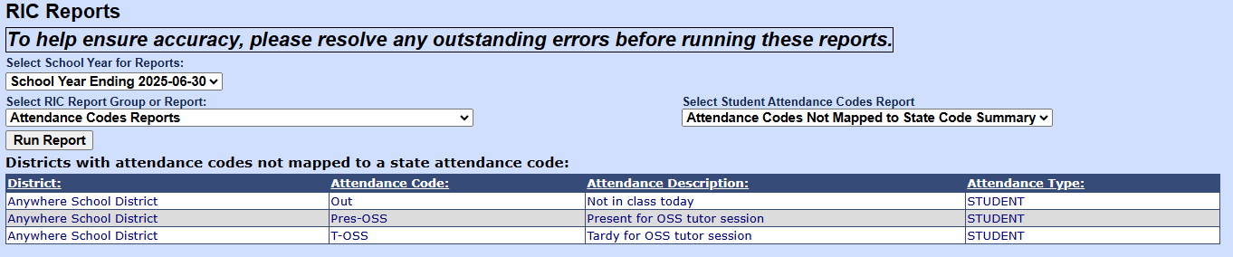

Assessment Fact
Purpose: Manual Assessment fact screen contained unneeded text boxes, appearing cluttered.

Removed extra fields on Manual Assessment Fact screen
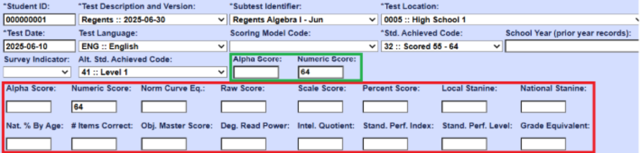

Demographics
Purpose: Need to be able to search by NYSSIS ID

Added a new box in the search bar and rename 'Student ID' to 'Local ID.'
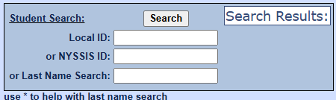

User Access Restriction Option
Purpose: Restrict users from logging in when maintenance is being done in Level 0

- Set in the 'Level 0 Options' screen.
- Only RIC_SU can login while this option is set to 'ON'.
- A message would notify users that Level 0 is currently in Maintenance Mode.

