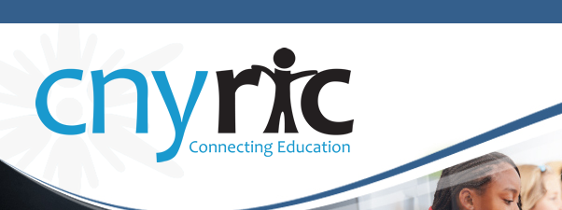
Central New York Data Analysis Community (CNYDAC)
Dec. 11, 2014
Time: 10:00 AM- 12:00PM
Distance Learning Center Room – OCM BOCES Admin. Building

The CNY Data Analysis Community (CNYDAC) exists to provide direction, expertise, and support to component schools for the intelligent and responsible use of data to improve student achievement.

- Welcome
- Current Issues in Data and Instruction
CNYRIC staff will facilitate a structured dialogue on current issues, asking all to contribute their struggles and successes related to a variety of topics.
- Using Item Study Maps and STAR Data in Collaborative Study Teams
Michelle Robinette, CNYRIC
- Reflection and Evaluation

