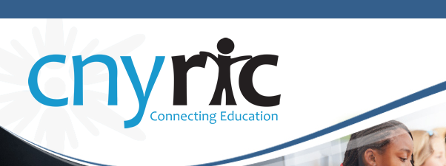
Central New York Data Analysis Community (CNYDAC)
February 12, 2015
Time: 10:00 AM- 12:00PM
Distance Learning Center Room – OCM BOCES Admin. Building

The CNY Data Analysis Community (CNYDAC) exists to provide direction, expertise, and support to component schools for the intelligent and responsible use of data to improve student achievement.

- Welcome
- Using Data from Common Core Module Assessments - Chris Klivak (15 Min.)
- NY State 3-8 Assessment Trend Maps - Kelly Malone (15 Min.)
- High School Accountability Data - Shawn Morgan (15 Min.)
- Diploma Eligibility Data - Jeremy Dodds (15 min.)
- Using Data at the District, School, Class and Student Level - Naomi Ludwig (45 Min.)
- Reflection and Evaluation

